Hands-on Exercise No. 1
AI Using Python
DigiSkills 3.0 – Batch 03
Name: Zain Ul Abidin

Task 1: Tax Calculator using Conditional Statements
Code:
(Insert Screenshot Here)
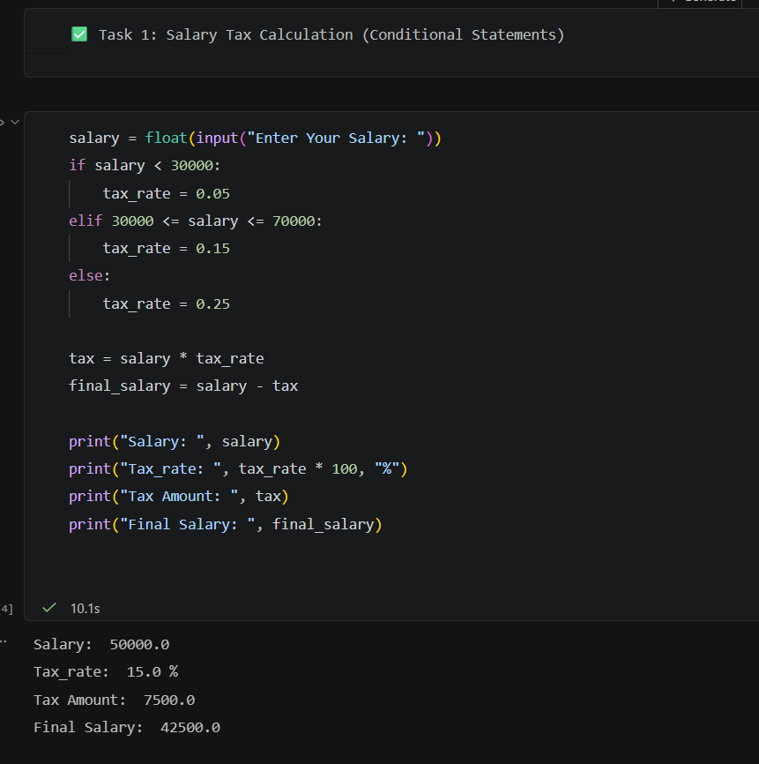
- Python code
- Input (e.g., salary entered)
- Output (tax calculated)

Output Explanation (1–2 lines):
The program calculates tax based on salary ranges:
- Below 30,000 → 5%
- 30,000–70,000 → 15%
- Above 70,000 → 25%

Task 2: Dictionary Creation from List
Code:
(Insert Screenshot Here)
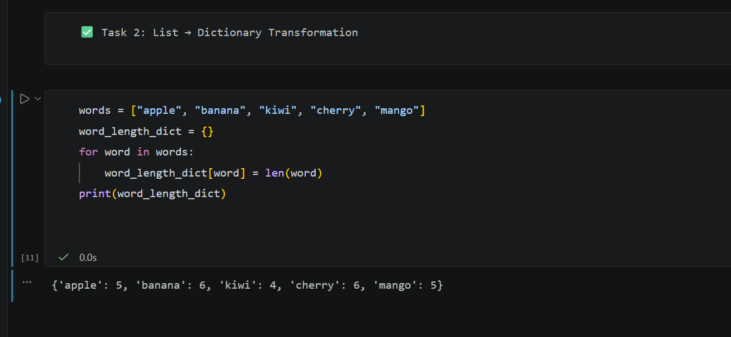

Output:
(Insert Screenshot Here OR write below)
{'apple': 5, 'banana': 6, 'kiwi': 4, 'cherry': 6, 'mango': 5}

Explanation:
A dictionary is created where each word is mapped to its length using Python.

Task 3: Chat System using OOP
Code:
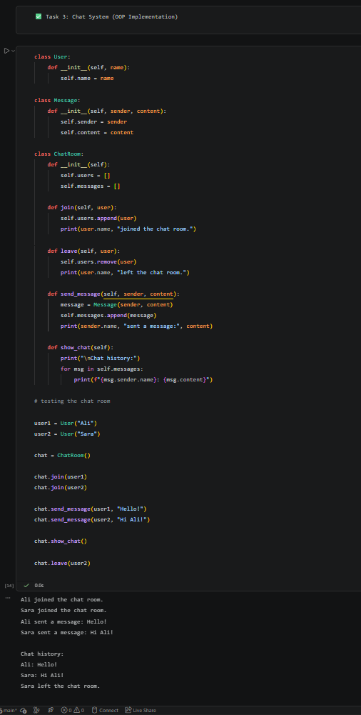

Example:
Ali joined the chat.
Sara joined the chat.
Ali: Hello!
Sara: Hi Ali!
Chat History:
Ali: Hello!
Sara: Hi Ali!
Sara left the chat.

Explanation:
This program demonstrates Object-Oriented Programming using:
- User class
- Message class
- ChatRoom class
It supports:
- Sending messages
- Viewing chat history
- Users joining/leaving

